On creating the environment to change the SG Electrical Condition status of an asset, the field is chosen and a drop down field is revealed wit the current status “ticked”
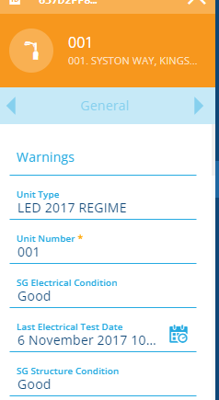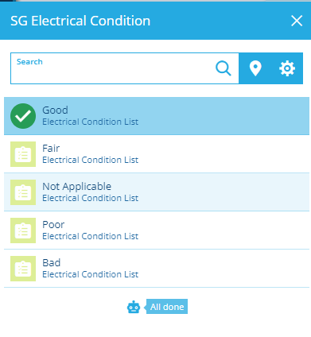

On selecting a new status i.e. Good to Fair, you can click the Fair option from the same list and Good is deselected automatically and the tick is generated and the system automatically returns you to the GENERAL tab with your new status populated for you to complete the task by clicking SAVE.
Why doesn’t the SG Structure Condition field “update” follow with that same intuition?
Now you have to select and deselect manually, and you could in error select and save more than 1 status.
