Sequencing waste containers via Drag and Drop

1. 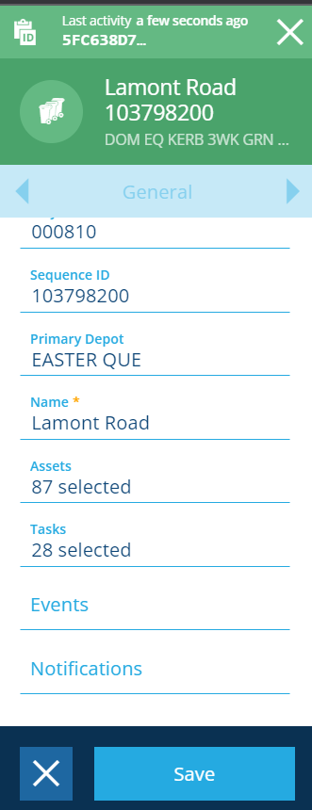Search waste group ID: **5fc638d77db3e80065ff5f57**

Click to edit, then assets.

1. Click selected.

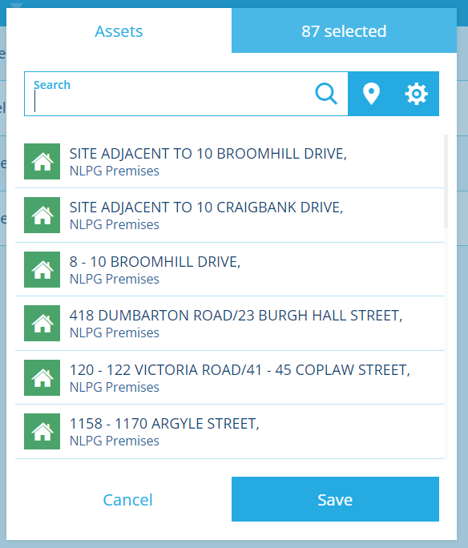

1. 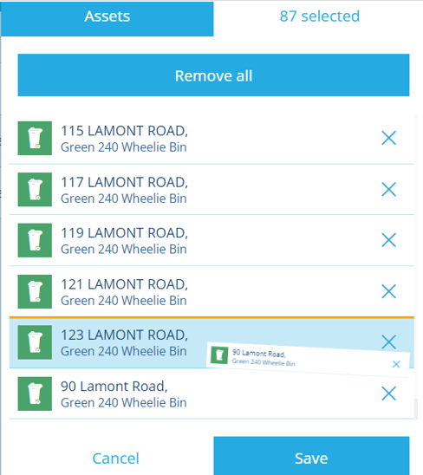Drag and drop waste container (90 Lamont Road) to desired sequence
2. 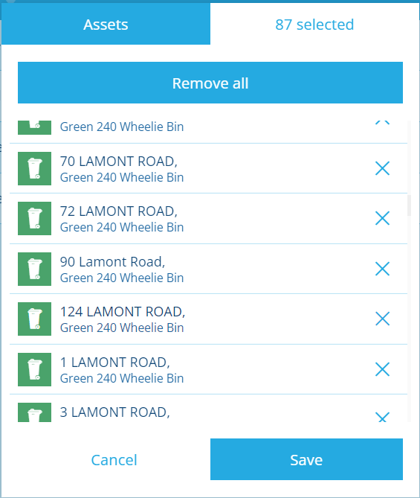Click on save once the container has been moved